**ASSIGNMENTS ON DIGITAL MARKETING**

**NAME:** SRIKANTH.E

**DEPARTMENT:** B.E ELECTRONICS AND COMMUNICATION ENGINEERING

**NAANMUDHALVAN COURSE:** DIGITAL MARKETING

**NM ID:** 1F039886AAA9F3296E0465D08E50BFD2

**COLLEGE**: 8151-DHANALAKSHMI SRINIVASAN INSTITUTE OF

TECHNOLOGY SAMAYAPURAM,TRICHY

**ASSIGNMENTS DESCRIPTION**

**1.Create the blog or website using blogspot and wordpress.customize the theme design and post new article with 500 words.**

<https://wordpress.com/posts/bluemoonphotograph.wordpress.com>

**2.Create a new facebook business page and post one social media poster for your brand.**

<https://www.facebook.com/profile.php?id=61551573466384&mibextid=ZbWKwL>

**3.Create and design a social media advertisement poster using canva.**

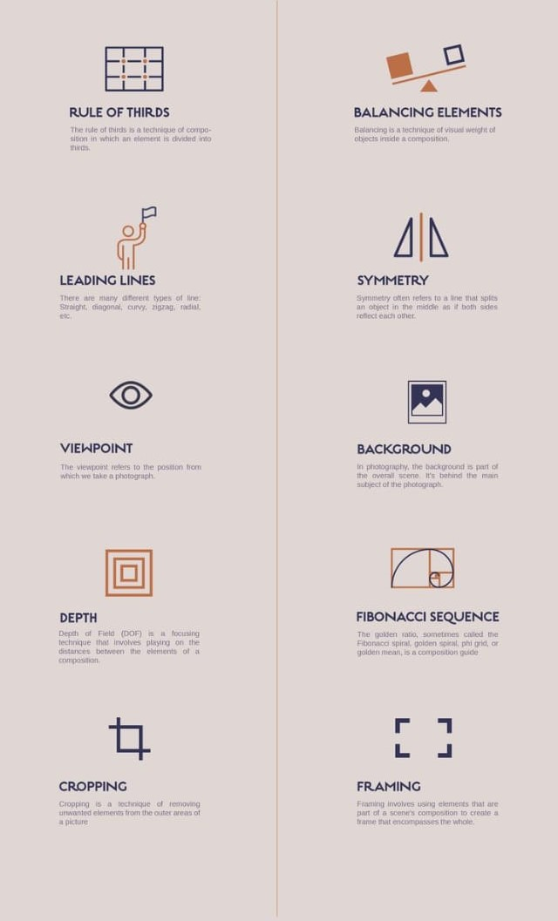

**4.Create email newsletter design using mail chimp or canva tool.**

